# Image result for victoria university sydney logo

# **GROUP-2**

# **ASSIGNMENT**

# **GROUP ESSAY REPORT- CASE STUDY SYSTEM**

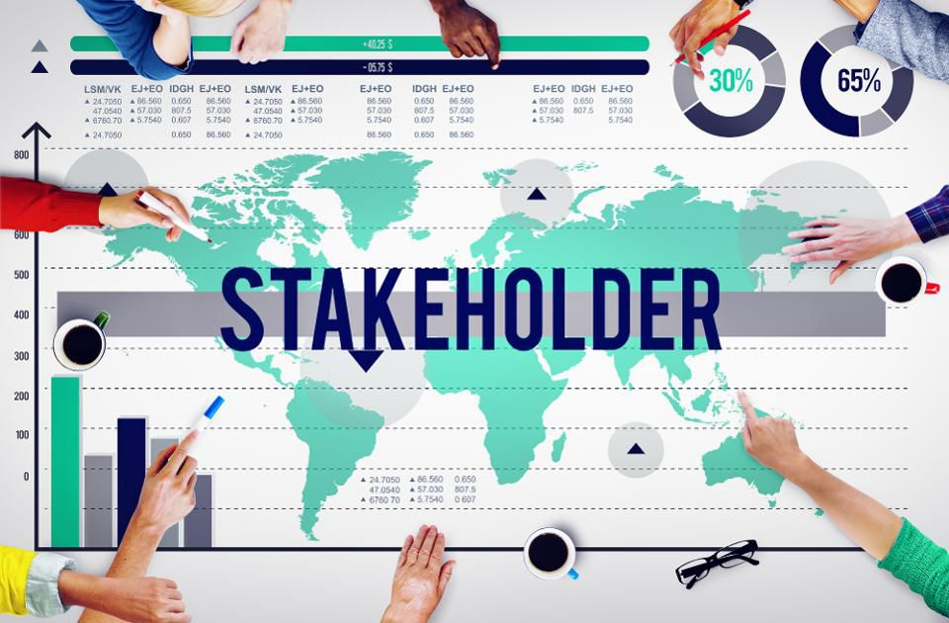

**SUBMITTED TO- SUBMITTED BY-**

DR. CLAIRE SURBHI DHAWAN (4608520)

# TABLE OF CONTENT

INTRODUCTION……………………………………………………………………………….3

PROJECT STAKEHOLDER MANAGEMENT………………………………………….3

BRIEF SUMMARY………………………………………………………………….............4

ISSUES/ CHALLENGES……………………………………………………………………….8

APPLIED STAKEHOLDER THEORY……………………………………………………..10

NEW SOLUTION……………………………………………………………………….........11

CONCLUSION…………………………………………………………………………………..12

REFERENCES…………………………………………………………………………………….13

# **INTRODUCTION**

Stakeholders are the people who have an interest in the project and have the ability to affect or become affected by the project outcome. In any project, stakeholders play a significant role and without their support, the project is unable to reach its goal. Stakeholders may affect the project positively or negatively and may live inside or outside the organization (Boaventura et al. 2019). The impact of the stakeholders is decisive for the achievement of failure or success of the project. By offering economic, functional and tactical assistance they add importance to any firm or project (Carvalho et al. 2018).

There have to be many milestones to be addressed and achieved for any major projects or systems. This study covers a system based on a construction scheme which identifies and categorizes stakeholders based on the interest, authority and many more variables and how they can be integrated into the scheme.

## **PROJECT STAKEHOLDER MANAGEMENT**

 The involvement of stakeholders in a project helps to build a healthy environment forming good relations with stakeholders. This contributes to achieving projects objectives and goals reducing any possible risks that come under (Schuck 2017). Stakeholder management helps a project manager to identify the stakeholders, understand their roles and impact on the project thereby finding ways to manage and engage them. It further helps to engage stakeholders to create the appropriate leadership policies throughout the whole cycle of the project (Eskerod and Jepsen 2106). Stakeholder theory contributes to project management by enhancing stakeholder’s interest in the project.

The stakeholder management involves four major stages which are:

* **Identify stakeholders:**

The first stage in stakeholder management is to identify all the feasible stakeholders (Lenssen 2007). Brainstorming, study, research, lessons learned, etc. can be carried out for the process of stakeholder identification.

* **Stakeholder Analysis:**

Next stage is to analyse all stakeholders engaged in a project after all the stakeholders have been identified. This provides an understanding of the strength, impact, and appeal of every stakeholder who is directly or indirectly involved in the project.

* **Manage Stakeholder:**

Communication is created between stakeholders to ensure their satisfaction and interest in the project on the basis of the Stakeholder management plan. After developing policies or plans to involve stakeholders, those policies must be implemented to handle stakeholders (Hart and Sharma 2004). For this process, the communication methods that stakeholders can use in the project and obtain their long term involvement are incorporated. Stakeholders are advised during this phase and ensure that their requirements are fulfilled.

* **Control Stakeholder Engagement:**

The implementation of the stakeholder management plan for the stakeholders, control of stakeholder participation is one of the most important tasks for the successful execution of any project. It enables to guarantee that the leadership strategy is effective in a particular project. This stage includes the results of the implementation of the stakeholder management of the interested stakeholders (Andriof and Waddock 2017). This evaluation is carried out in any project through feedback, frequent conferences and a debate of their views on a specific issue.

# **BRIEF SUMMARY OF STAKEHOLDER ANALYSIS IN CONSTRUCTION SYSTEM**

Project that has been discussed in this paper is the construction of new hotel with five-star rating with the total budget of 50 million dollar. The total time frame for this project is 9 months. Overall stakeholders involved in this construction system can be analyzed to better understand the system and evaluate the feasibility of the project. According to stakeholder theory, identifying stakeholder is overall method of finding out overall stakeholders involved according to power, influence and impact (Lenssen et al. 2007).

**The stakeholders of construction system have been classified into two types which are:**

## **As per impact and power**

1. **Primary and Secondary Stakeholders**

Primary stakeholders are directly involved in the project and have more impact and power in the project. Project manager, government, project sponsor, project team members, project client, sub-contractors, supplier contractors are the primary stakeholder for this project. Primary stakeholders such as construction manager, client, project team members, customers, government and local community are in high priority as their active involvement determines the status of project.

Secondary stakeholders of this system involved those stakeholders who are not directly involved in the project. As per power and impact, secondary stakeholders have comparatively less power and impact in the project. Examples of secondary stakeholders are local communities, customers, competitors and society.

## **As per environment**

1. **Internal and External Environment**

All the stakeholders within the system comes under internal environment. These are client, construction managers, financial service providers, engineers, technicians, contractors, sub-contractors, project ream members. These stakeholders have direct involvement in the project.

The stakeholders involved outside the system comes under external environment. These are costumers, government, local communities and competitors. These stakeholders are external stakeholders who are not actively involved in day to day basis of project but can affect the project if not handled in an appropriate manner.

|  |  |  |  |  |
| --- | --- | --- | --- | --- |
| Stakeholder | Description | Influence | Contribution | Internal or external |
| Client | The owner of hotel | high | Provides budget | Internal |
| Construction Manager | Main person to overlook the project | high | Handles entire project | Internal |
| Project team members | Employees, staffs, who execute the project | high | Responsible for day to day activities and run the project | Internal |
| Suppliers | Equipment, raw materials suppliers | medium | Provides necessary equipment, materials for the smooth operation. | Internal |
| Customers | Main client | High | Workflow of the project. | External |
| Government | Regulatory authorities | high | Set legal rules and regulations. | External |
| Competitors | Other construction agencies | Low | Gives motivation and set standards for performance | External |
| Local community | Neighborhood buildings | High | Is responsible for  acceptance of the project and create a  friendly  atmosphere | External |

*Fig: Stakeholder Identification*

Next step after identifying stakeholders is stakeholder analysis which provide a clear idea of power, interest and involvement of stakeholders in the project. The stakeholders of this project have been analysed by using power vs interest grid (PMBOK 2003 cited by Waseileski 2017).

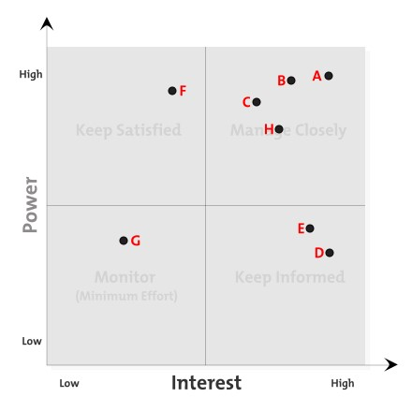

*Fig: Power Interest Grid*

According to this grid, the stakeholders that must be managed closely are client, construction manager, project team members, suppliers, local community. Government must be satisfied; suppliers and customers must be kept informed. Competitors should be monitored.

Stakeholder analysis also provides the engagement strategy which assist to involve all the stakeholders in an appropriate manner. Stakeholder engagement strategy for this project can be summarized as follows:

|  |  |  |  |  |  |  |
| --- | --- | --- | --- | --- | --- | --- |
| Code | Stakeholder | Involvement | interest | Influence/ power | Management  Strategy | Engagement  Strategy |
| A | Client | High | High | High | Manage  Closely | Keep informed and Satisfied with frequent communication |
| B | Construction manager | High | High | High | Manage  Closely | Follow up regularly |
| C | Project team members | High | High | High | Manage  closely | Frequent meeting and updates |
| D | Suppliers | Low | High | Low | Keep informed | Daily follow up |
| E | Customers | Low | High | Low | Keep informed | Involving by showing progress |
| F | Government | High | Low | High | Keep  satisfied | Follow up with the project |
| G | Competitors | Low | Low | Low | Minimum  effort | Asking opinions |
| H | Local Community | Low | High | High | Manage  Closely | Interaction programs |

*Fig: Stakeholder Analysis*

Client has direct impact in the project. They should be kept informed about the progress of the project as it is vital to satisfied them with frequent communication. Construction manager, suppliers and government must have up to date information about the progress of project. Frequent meetings and updates should be given to all the team members. Competitors can be engaged for opinions. Costumers and local communities can be engaged with interaction programs.

# **ISSUES/ CHALLENGES:**

* **Unrealistic Expectations:** It is a greater concern for Project managers to manage the unexpected desires of the stakeholders at different stages of project. Sometimes the requirements of stakeholder changes with ongoing projects. To meet their demands, they follow different strategies so that other members fulfill their demands. The strategies they follow are: usage, withhold, direct and indirect. Either they will stop providing the resources or will provide by applying constraints to it. If they are other stakeholders, then they can boycott the company in order to fulfil the demands.
* It is impossible to satisfy every stakeholder. Some will not like the budget estimates or features you are providing in the project.
* This challenge arises when there is a communication gap between managers and stakeholders, or features does not match the actual delivery of the project.
* **Lack of interest or involvement:** It is very important to engage the stakeholders throughout the project. To keep them on same page, stakeholder engagement is very important. Sometimes when stakeholders lack interest in the project due to no profits or positive responses they may back out or start losing interest from the project which may lead the company in adverse bad situation. So, involving stakeholders is key part of the success of project.
* **Stakeholders are reluctant to share information:** one of the baffling issues arises is attempting to cajole the viral information out of stakeholders. Stakeholders may go to gatherings and participate in building up an answer, however it requires a huge exertion to convince them to impart any pertinent information to you. This may be due to past bad experiences of stakeholders which may feel them of no significance to give information straightforwardly.
* Possibly they are alright with the way things are going at this moment and don't see the requirement for change. Or then again, perhaps the partner knows about specific issues in office arrangements that he doesn't feel he can impart to the undertaking administrator.
* **Negative Stakeholders in Working Phase:** Negative stakeholders are those who don’t have direct relation to the project but have impact due to success of the project. They may arise problems related to ongoing project or can have bad impact overall of project. It is very important to keep these types of stakeholders away from the project. They can be the competitors in the market, or they can be the contractors that are involved in the project.
* Budgetary partners, for example, associations and materials providers, can utilize their impact and generation to request more prominent monetary advantage.
* Political partners can likewise utilize the undertaking to charm themselves to casting a voting blocks and political contributors.

# **APPLIED STAKEHOLDER THEORY**

By participatory and systematic observation, evaluation and interpretation of behaviour, the organisational context could be realized and perceived and the leadership of stakeholders better understood. The primary theoretical framework used to create scheme for a management and engagement strategy for stakeholders is based on PMBOK (PMI 2017). In this fresh strategy, a stakeholder workshop has been implemented. This sort of focus group, working without a strict framework and through free-flowing debates, counts with the biggest number of main stakeholders of the project. The artefact "Stakeholder Engagement" includes a stakeholder register sheet, which is an enhancement to the Bosch PMO model.

**The present stakeholder management procedures are:**

1. **Identify stakeholders**
   * Carrying out a workshop for stakeholders after identification of stakeholders
   * Including the "Stakeholder Register" document of a "Work History" column

1. **Plan stakeholder engagement**
   * Developing a table with the differences between the present and the future so stakeholder’s dedication is required for the project. Planning the whole project in starting is a huge milestone for the project to achieve its goal.
2. **Manage stakeholder engagement**

* Managing stakeholder is the important part of the project as it can lead to the success and failure of the project. Engaging them in the project is necessary so that the final result comes out to be the best. There can be different ways of managing them in the project.

1. **Monitor stakeholder engagement**

* Creating a cover sheet in the document "Stakeholder Engagement" that contains all the charts and tables previously which are already produced and functions as a working environment for the project manager.

# **NEW SOLUTION OF THE ISSUES**

As mentioned in the above theory there are 4 main procedures to solve the issues in any project. Identifying stakeholders has been done properly in the report as all the stakeholders are mentioned with the interests and power on the project. The solution for the above mentioned issues can be solved by monitoring stakeholder as it is very important to monitor the stakeholders so that they don’t lose their interest in the project and supports the project till the end.

The solutions for the issues are-

* By having proper discussion in the initiation phase of the project with the stakeholders and the client which will include all the policies, rules and privacy concerns from the company view. Change of any requirement and demanding anything new in the project will need time and monitoring of the stakeholders.
* By having regular meetings with the stakeholders and keep them informed about the project based on the priorities of the stakeholders. Meetings can be held weekly, monthly or after half of the finishing of the project. It will include presentations, reports, graphs, tables etc. so that their interest remains in the project.
* By making stakeholders this much comfortable that they can share the information without any fear by involving them in the project, by ensuring them the privacy of their information and letting them have arrivals on the sites and monitor the situation of the project by themselves.
* By keeping all the stakeholders happy especially the negative one’s which can be the neighbourhood buildings who will feel the competition is coming for them and they can start filing wrong complaints about the project. This can be done by having communication with them whenever is required so that you can get to know them and make good relations so that they don’t create any problems and monitor them on regular basis.

# **CONCLUSION**

In the end it can be concluded that there is no such problem/ issues which cannot be resolved. In this case, monitoring the stakeholders for the given issues can be the best solution as this will let us know the state of mind of the stakeholder and how much they want to involve in the project and managing them in the right direction is beneficial for the project. The stakeholder theories given by various people helps a lot in getting the problems solved. Any project is successful only when the stakeholders are happy with the work and they have their complete contribution in making of the project, then even the reputation and hard work of the team will be acknowledged.

# References

Andriof, J. and Waddock, S., 2017. Unfolding stakeholder engagement. In *Unfolding stakeholder thinking* (pp. 19-42). Routledge.

Boaventura, J.M.G., Bosse, D.A., de Mascena, K.M.C. and Sarturi, G., 2019. Value distribution to stakeholders: The influence of stakeholder power and strategic importance in public firms. *Long Range Planning*.

Carvalho, H.J.F., Tereso, A.P., Fernandes, A.G.G., Faria, J.M.P. and Barbosa, J.F.N.D.S., 2018. Stakeholder management in industrialization projects: an automotive industry case study.

Eskerod, P. and Jepsen, A.L., 2016. *Project stakeholder management*. Routledge.

Lenssen, G., Perrini, F., Tencati, A., Lacy, P., Holmes, S. and Moir, L., 2007. Developing a conceptual framework to identify corporate innovations through engagement with non‐profit stakeholders. *Corporate Governance: The international journal of business in society*.

Hart, S.L. and Sharma, S., 2004. Engaging fringe stakeholders for competitive imagination. *Academy of Management Perspectives*, *18*(1), pp.7-18.

Schuck, A.M., 2017. Prevalence and predictors of surveillance cameras in law enforcement: the importance of stakeholders and community factors. *Criminal justice policy review*, *28*(1), pp.41-60.

Lenssen, G., Perrini, F., Tencati, A., Lacy, P., Holmes, S. and Moir, L., 2007. Developing a conceptual framework to identify corporate innovations through engagement with non‐profit stakeholders. Corporate Governance: The international journal of business in society.

Wasieleski, DM & Weber, J (Business ethics professor) 2017, Stakeholder management. [electronic resource], Business and society 360, Bingley, UK : Emerald Publishing, 2017.,